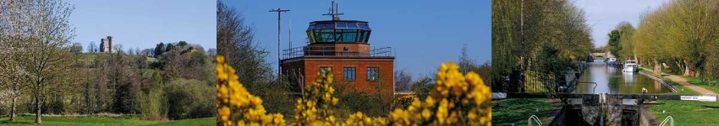

Council Report for June 2023

Written by your local Conservative team to keep you up to date.

Cllr Dominic Boeck

Aldermaston Ward

West Berkshire Council

Council
There was no meeting of Council this month.
The next meeting is on 20 July.

Executive
Executive met on 8 June to discuss:
- Noted the Capital Financing Performance Report Outturn 2022/23
- Noted the 2022/23 Revenue Financial Performance Quarter Four: Provisional Outturn
- Noted the 2022/23 Performance Report Quarter Four/Year end
- Approved the Delivery of the Local Authority Housing Fund recommendations
- Approved the Hackney Carriage Tariffs - 2023 recommendations
Papers and a recording of the meeting can be found here.
The next meeting is on 6 July.

Leisure

New Leisure Management Operator will keep ‘Everyone Active’
This year is set to be the start of an exciting time in leisure for West Berkshire. From 1 July, Everyone Active will begin a ten-year contract to run Northcroft Leisure Centre and Lido, Hungerford Leisure Centre, Kennet Leisure Centre, Cotswold Sports Centre, Willink Leisure Centre, Lambourn Sports Centre and the Downland Sports Centre.
The new contract will have a strong focus on community outreach, providing a variety of creative and physical activities in local venues such as community halls, churches and outdoor locations to make sure that everyone can access the activities they love.

Sporting Champions
Up-and-coming athletes in West Berkshire are being given the chance to become ‘Sporting Champions’ and gain much needed support as part of a sports talent development scheme.
WBC’s new leisure operator, Everyone Active, has already helped thousands of athletes to achieve their sporting potential through the Sporting Champions programme. Applications opened on Saturday 1 July.
Successful athletes will receive free access to Everyone Active’s 200+ leisure facilities across the country, including all of West Berkshire Council’s leisure and sports centres, plus mentoring from Olympians and Paralympians including Lutalo Muhammad, Jennifer and Jessica Gadirova, Richard Kilty, Lauren Steadman, Kadeena Cox and Maisie Summers-Newton.
Residents can apply to be a Sporting Champion until 14 July: easportingchampions.com/how-to-apply/

Northcroft Lido - Splashpad Arrives!
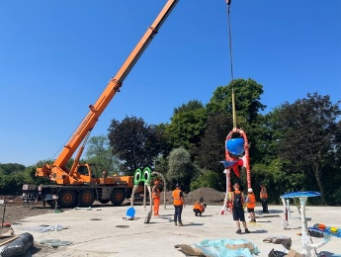
It's all coming together down at the Lido and things are looking great. The splash pad is being installed and the pool lining is coming along nicely too. Contractors are now preparing to install the slides and lay the decking which will be in the up-and-coming weeks. Keep an eye on WBC socials for more updates in the coming weeks.
Watch the video update online at: youtube.com/watch?v=T3wWMPrEfxo

Environment

Green Waste
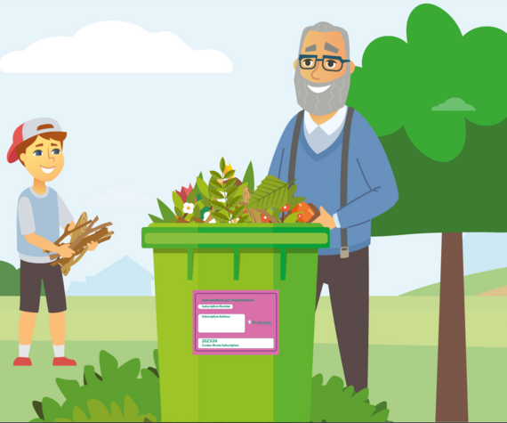
Residents who currently subscribe to the garden waste collection service by Direct Debit should have received an email containing their renewal details.
If all details are correct they do not need to do anything to renew, it is as simple as that! If there is a need to change any details, they can follow the instructions in the email.
New subscribers to the garden waste service, or those who pay by credit/debit card, will receive further details shortly to explain how to sign up or renew.

Busloads of food waste recycled!
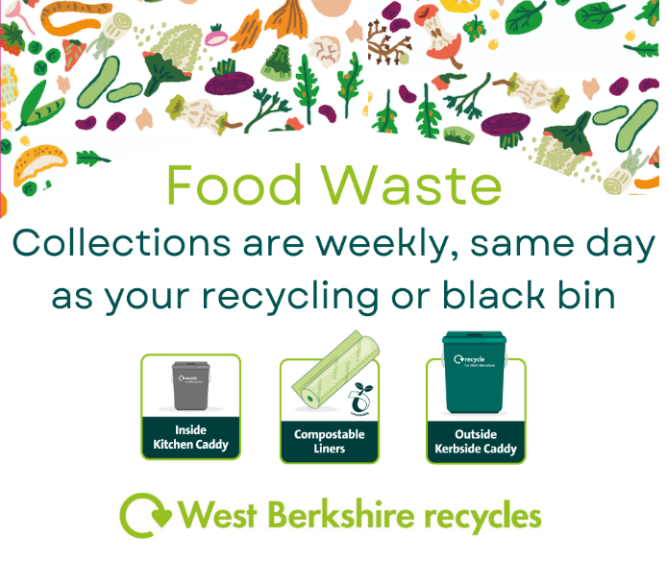
Thank you to everyone who is recycling their food waste through the weekly kerbside collection service. So far, WBC have collected in total over 2,400 tonnes of food waste. That is roughly the same weight as 200 double decker buses!
Over the next few weeks residents will see stickers being placed on all black rubbish bins across the district saying 'No food waste'. This is because there's still a lot of food waste that is being placed in black bins that can be recycled easily using the food waste caddies.
This was brought in by the previous Conservative administration as recycling food waste is good for the environment - so let's work together to recycle more.

West Berkshire Big Community Switch
This service helps residents switch energy suppliers and save money, while also supporting a greener future with 100% renewable energy tariffs.
The service is easy to use, free and there is no obligation to switch to the winning supplier once you receive your personal offer. The more people that participate in the scheme, the more likely we will be able to get a better deal for you. Spread the word and tell your family, friends and neighbours.
For more information, or to register with no obligation to switch, residents can visit bigcommunityswitch.co.uk/west-berkshire/home.

Economy

Summer Holiday Activities and Food programme
The popular HAF scheme is running again this summer. There will be a wide range of both established and new providers offering exciting and rewarding activities. These include paddle boarding, rock climbing, arts and crafts and a nutritious meal (included in all bookings).
HAF is free for children in full time school aged 4 -16 who receive Free School Meals. Bookings and additional information will be live on the WBC website soon.

Growth Hub Support

Masterclasses
WBC are offering a series of Masterclasses on leadership, finance, sales & marketing and digital marketing.
- Learn about cash flow management and funding opportunities
- Discover the importance of vision and how to get more out of your staff
- Identify your target market and understand how to close that sale
- Understand how to implement simple strategies for success and produce the right content
Explore the Masterclasses and book a place:

Leadership & Your People – 11 July 2023
Understand the fundamentals of leadership that will provide both insight and an opportunity for self-reflection. Register now >

Sales & Marketing – 19 July 2023
Transform your approach to sales & marketing. Participating will help you gain new perspectives, inspire new ideas and change your way of thinking. Register now >

High-Growth Programmes
For established businesses ready to reach their full potential but in need of support, there is also the High Growth Programme. The programme is delivered by the Berkshire Growth Hub and aims to help reach and exceed business goals by implementing those ideas. Offering up to 12 hours of intensive support tailored to your business, the programme is delivered through 1-2-1 sessions and Masterclasses. It’s designed to support businesses in seizing opportunities to grow by leading more effectively, generating more customers and turnover, scaling up and bringing new products and services to market.

Education

Numeracy
WBC’s community learning team is offering a range of short, on-line numeracy courses in topics such as working out bills, understanding payslips, calculating weights and measures or supporting children to do their homework. The courses are free of charge and are perfect as a revision exercise or preparing you to move on to further learning.
- Click here for further information about the Multiply on-line programme
- To access the courses simply enrol here.
- Once enrolled you’ll receive a link to the Multiply programme site to activate your account and start a course.
All courses are non-accredited (no qualification) and delivered at the learner's pace. You can drop in and out of the course at any time.
For more information contact the community learning team by email on aclteam@westberks.gov.uk or on 01635 519060.

Public Protection

Dog Safety
As a nation of dog lovers, dogs are often part of the family, so it's vital that both parents and children have the knowledge they need to enjoy spending time with dogs safely.
Dog bites can happen because of certain circumstances or because owners miss important signals from dogs. Following the Dog Safety Code can help to prevent that from happening: https://www.cfsg.org.uk/dog-safety/

Culture

Ukrainian book launch
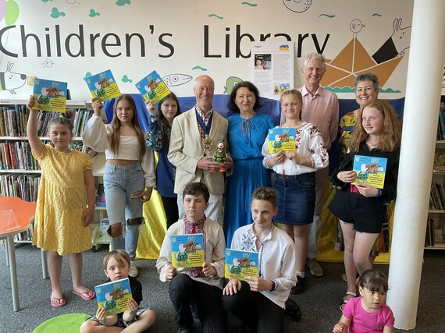
Ukrainian artist Nadia Sadoviak has launched her special book of poems to help the children of Ukraine understand and cope with the impact of the war at Newbury Library.
Nadia has worked as a music teacher for 25 years, she loves teaching children and creating positivity through music and has added poetry and art to her teaching tool box.
Nadia said:
“I think about helping children all the time. I’m always trying to find new ways to connect with them and create positivity. Although it is not possible to find positivity about the terrible situation in Ukraine, I’ve had positive feedback about how useful children there are finding this book to help them cope with a situation they can barely understand.”
“I have made copies of the book and launched it in Newbury, where I live, to share it with as many Ukrainian children here as possible.”
The book features a series of poems featuring a ‘Brave Goose’, shown in many guises and roles including a medic, a volunteer and even as the singer from Ukrainian Eurovision winning band, Kalush Orchestra.

Archaeological Discovery in Berkshire
The oldest decoratively carved wood in Britain has been found in West Berkshire. Discovered by chance during construction in Boxford, it has been identified as being more than 6,000 years old and will eventually be on display at West Berkshire Museum.
Further reading: https://historicengland.org.uk/whats-new/news/oldest-decoratively-carved-wood-in-britain-boxford-timber/

Summer Reading Challenge 2023: Ready, Set, Read!
After the success of last year’s Summer Reading Challenge, West Berkshire Libraries will be challenging primary age children to read up to six library books between 1 July and 15 September with medals and certificates for everyone who completes the challenge.
The theme of this year’s challenge is ‘Ready, Set, Read!’ aiming to empower young people to unleash the power of play, sport and physical activity through reading. Children will be able to join a superstar team and their marvellous mascots as they navigate a fictional summer obstacle course brought to life with illustrations by children's illustrator Loretta Schauer.
There will also be a mini challenge for pre-school children and one for the grown-ups too!
The Summer Reading Challenge is a great way for children to keep up their reading skills and confidence over the summer holidays and prevent the common holiday ‘reading dip’.

Festival of the Moon
Newbury BID are bringing Luke Jerram’s Museum of the Moon art installation to the town centre for 3 weeks. Working in collaboration with the Corn Exchange and 101 Arts, the installation will be housed within the Corn Exchange auditorium from 15 August – 3 September which will be open to the public with free entry.
To coincide with the Museum of the Moon, Newbury BID are currently programming a “Festival of The Moon”. This will be a 3-week festival and they hope that as many town centre businesses as possible can get involved and arrange in-house moon related events or activities and directly benefit from the additional footfall. From music to meditation, astronomy and everything in between – all moon themed events are welcome.

Current Consultations
- Autism Survey 2023 – closes 19 July
- How safe do you feel in West Berkshire? – closes 30 July
- Memorial Fields Thatcham Flood Alleviation Scheme – closes 6 August

Parish Matters

Highways

Parking at Aldermaston Wharf
Inconsiderate parking continues to present severe problems to residents in and around Station Road. I want Highways to commit to considering what can be done to ease the situation and I will be asking a question along those lines at the Executive Committee meeting on 6 July.

Resurfacing of Back Lane, Beenham
In June, Highways met their commitment to resurface the nearly one-kilometre stretch of road from the A4 to Beenham Hill. Their contractor, Veolia have done an excellent job and they are to be commended.

Members’ Bids
Every year, there is an opportunity for elected members to bid for funding to support community groups and parish councils who have projects and initiatives that they want to deliver. The scheme has allowed me to help with projects such as renovating Aldermaston Parish Hall, making improvements to St Peter’s Church in Brimpton and the parishes’ speed reduction initiative.

This year, the scheme will open to bids some time from September on. The scheme is being reviewed and dates haven’t yet been finalised but if any parish council or community group would like to seek funding, they should start to develop their plans right away. Previously, grants have been made for up to £5,000 per elected member, subject to matched funding. Please contact me, if anyone has any ideas or questions.

Scrutiny Commission
Scrutiny is an important aspect of local politics and in West Berkshire the Scrutiny Commission is empowered to gather evidence on issues affecting local communities and residents and make recommendations. I have been appointed to the Commission as Vice-Chairman.

